Supporting Information

Optimized CNT-PDMS Flexible Composite and its Application in Attachable Health-care Device
Jian Du^{1,#}, Li Wang^{1 ,#,}*, Yanbin Shi^{1,}*, Feng Zhang¹, Shiheng Hu¹, Pengbo Liu¹, Anqing Li¹, Jun Chen ^{1,}* ,
¹School of Mechanical & Automotive Engineering, Qilu University of Technology (Shandong Academy of Sciences), Jinan 250353, China.
#Authors equally contributed
*Corresponding author: liwang@qlu.edu.cn, chenjun@qlu.edu.cn, syb@qlu.edu.cn; Tel.: +86-0531-8963-1702; Fax: +86-0531-8963-1702.

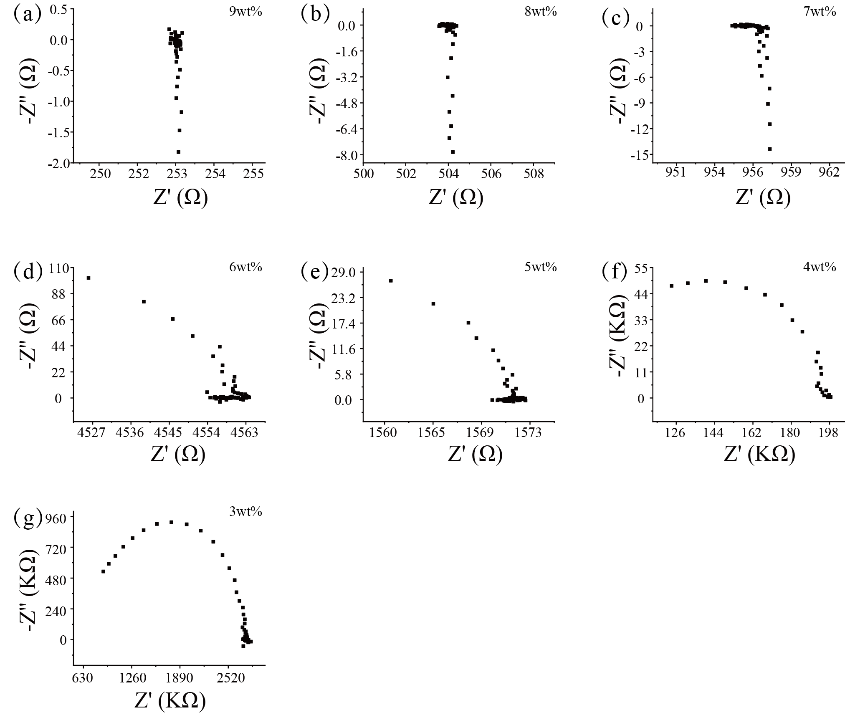
Fig. S1. (a-g) Impedance analysis of CNT-PDMS composite with different CNT mass fraction.

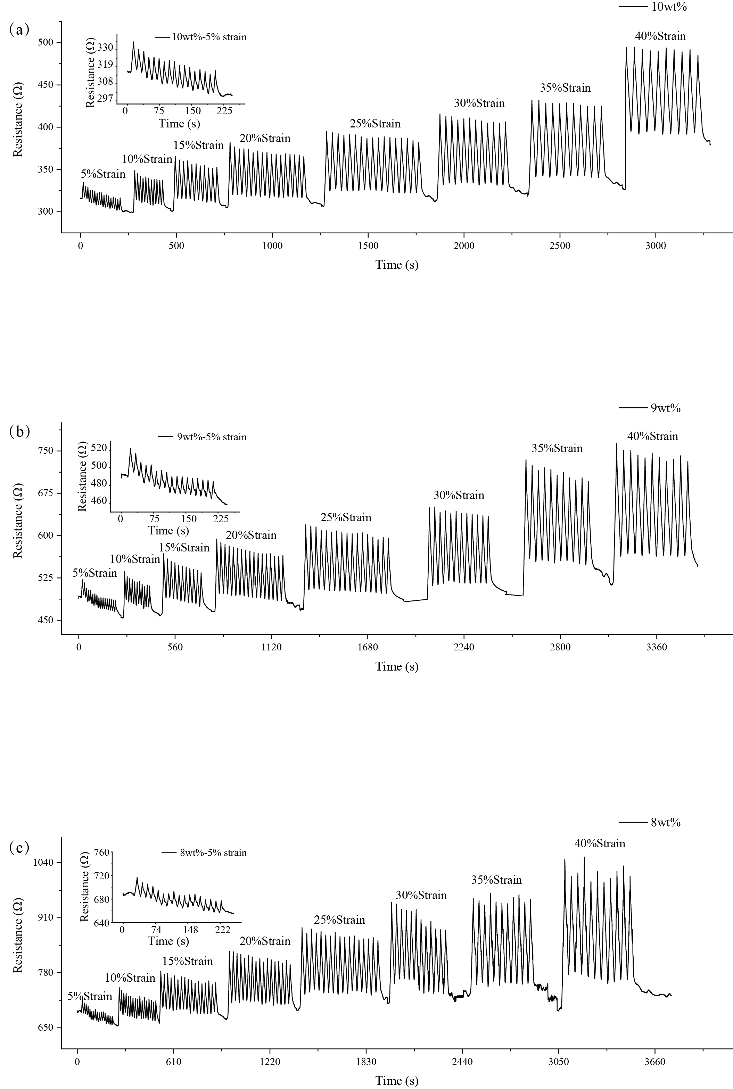

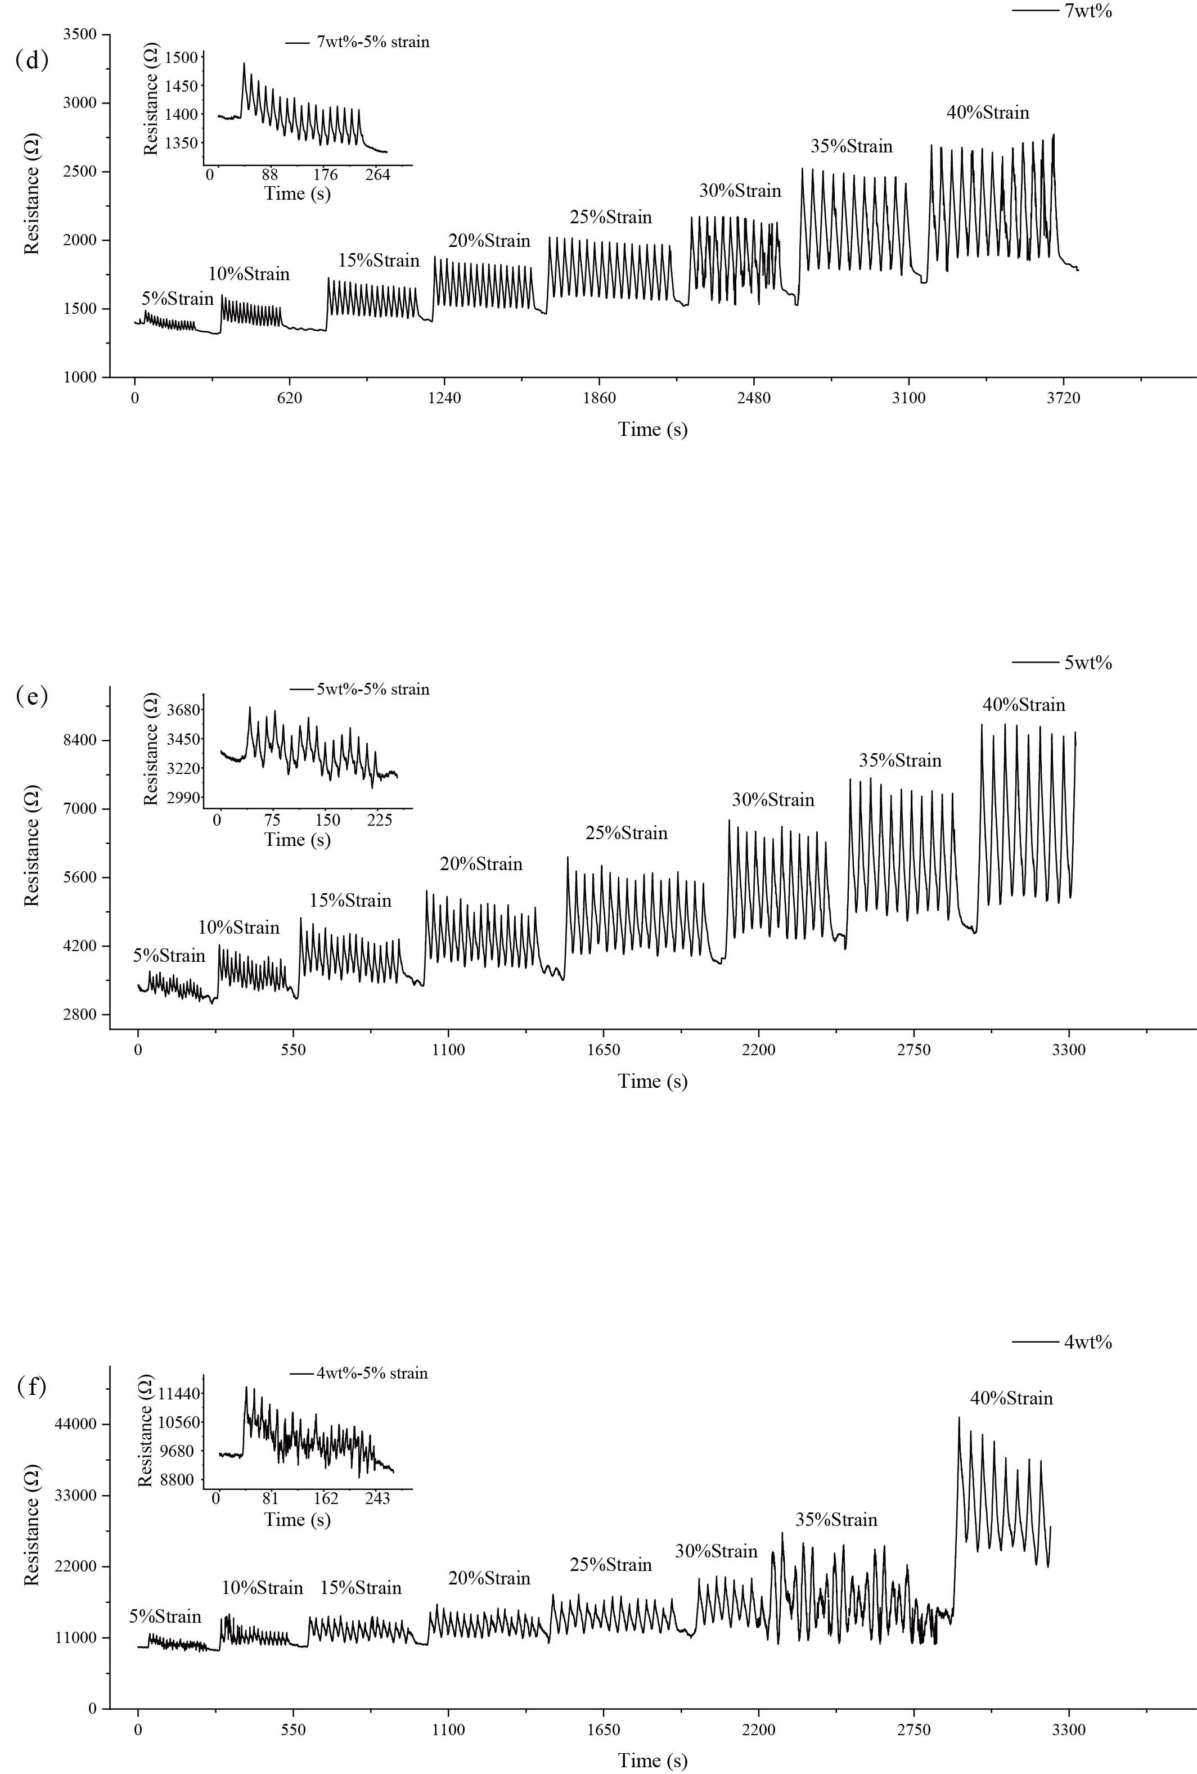
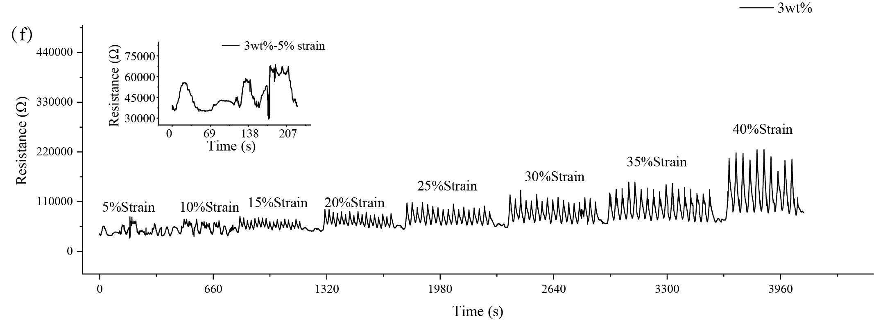
Fig. S2. (a-g) resistance change curves of different CNT mass fraction CNT-PDMS samples during stretching.

